**Experiment – 1**

**Verilog code for designing basic gates by using basic gates.**

**design.sv**module basic_gates(A, B, y_not, y_and, y_or, y_nand, y_nor, y_xor, y_xnor);  
 input A, B;  
 output y_not, y_and, y_or, y_nand, y_nor, y_xor, y_xnor;  
  
 not(y_not, A);  
 and(y_and, A, B);  
 or(y_or, A, B);  
 nand(y_nand, A, B);  
 nor(y_nor, A, B);  
 xor(y_xor, A, B);  
 xnor(y_xnor, A, B);  
endmodule

**testbench.sv**module basic_test();  
 reg A, B;  
 wire y_not, y_and, y_or, y_nand, y_nor, y_xor, y_xnor;  
  
 basic_gates basic_dut(A, B, y_not, y_and, y_or, y_nand, y_nor, y_xor, y_xnor);  
   
 initial begin  
 A = 0; B = 0; #10;  
 A = 0; B = 1; #10;  
 A = 1; B = 0; #10;  
 A = 1; B = 1; #10;  
 $finish;  
 end  
  
 initial begin  
 $dumpfile("test.vcd");  
 $dumpvars(1, basic_test);  
 end  
endmodule

**Output Waveform**

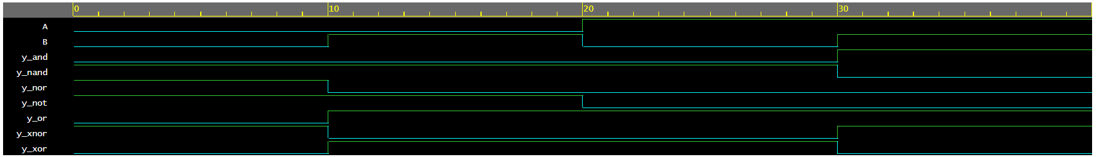

**Verilog code for designing basic gates by using NAND gates.**

**design.sv**module nand_basic_gates(A, B, y_not, y_and, y_or, y_nand, y_nor, y_xor, y_xnor);  
 input A, B;  
 output y_not, y_and, y_or, y_nand, y_nor, y_xor, y_xnor;  
 wire and_ab, or_a_not, or_b_not, xor_ab, xor_a_ab, xor_b_ab;  
  
 // NOT  
 nand(y_not, A, A);  
  
 // AND  
 nand(and_ab, A, B);  
 nand(y_and, and_ab, and_ab);  
  
 // OR  
 nand(or_a_not, A, A);  
 nand(or_b_not, B, B);  
 nand(y_or, or_a_not, or_b_not);  
  
 // NAND  
 nand(y_nand, A, B);  
  
 // NOR  
 nand(y_nor, y_or, y_or);  
  
 // XOR  
 nand(xor_ab, A, B);  
 nand(xor_a_ab, A, xor_ab);  
 nand(xor_b_ab, B, xor_ab);  
 nand(y_xor, xor_a_ab, xor_b_ab);  
  
 // XNOR  
 nand(y_xnor, y_xor, y_xor);  
endmodule

**testbench.sv**module nand_basic_test();  
 reg A, B;  
 wire y_not, y_and, y_or, y_nand, y_nor, y_xor, y_xnor;  
  
 nand_basic_gates nand_dut(A, B, y_not, y_and, y_or, y_nand, y_nor, y_xor, y_xnor);  
   
 initial begin  
 A = 0; B = 0; #10;  
 A = 0; B = 1; #10;  
 A = 1; B = 0; #10;  
 A = 1; B = 1; #10;  
 $finish;  
 end

initial begin  
 $dumpfile("test.vcd");  
 $dumpvars(1, nand_basic_test);  
 end  
endmodule

**Output Waveform**

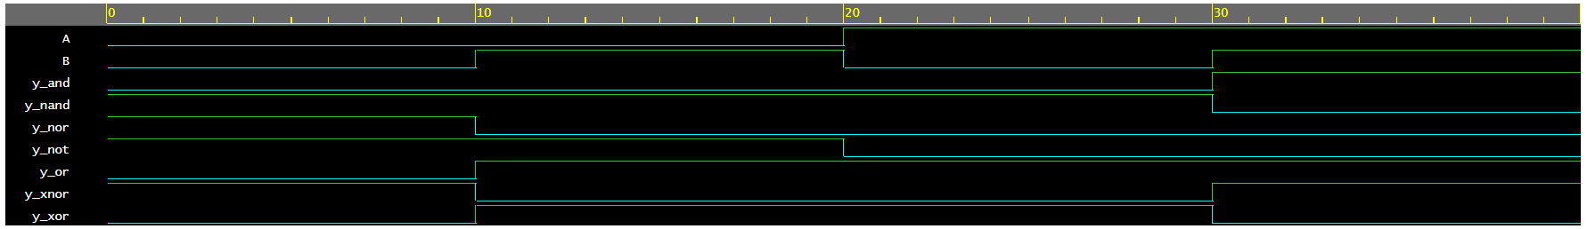

**Verilog code for designing basic gates by using NOR gates.**

**design.sv**module nor_basic_gates(A, B, y_not, y_and, y_or, y_nand, y_nor, y_xor, y_xnor);  
 input A, B;  
 output y_not, y_and, y_or, y_nand, y_nor, y_xor, y_xnor;  
 wire and_a_not, and_b_not, or_ab, xnor_ab, xnor_a_ab, xnor_b_ab;  
  
 // NOT  
 nor(y_not, A, A);  
  
 // AND  
 nor(and_a_not, A, A);  
 nor(and_b_not, B, B);  
 nor(y_and, and_a_not, and_b_not);  
  
 // OR  
 nor(or_ab, A, B);  
 nor(y_or, or_ab, or_ab);  
  
 // NAND  
 nor(y_nand, y_and, y_and);  
  
 // NOR  
 nor(y_nor, A, B);  
  
 // XOR  
 nor(y_xor, y_xnor, y_xnor);

// XNOR  
 nor(xnor_ab, A, B);  
 nor(xnor_a_ab, A, xnor_ab);  
 nor(xnor_b_ab, B, xnor_ab);  
 nor(y_xnor, xnor_a_ab, xnor_b_ab);  
endmodule

**testbench.sv**module nor_basic_test();  
 reg A, B;  
 wire y_not, y_and, y_or, y_nand, y_nor, y_xor, y_xnor;  
  
 nor_basic_gates nor_dut(A, B, y_not, y_and, y_or, y_nand, y_nor, y_xor, y_xnor);  
   
 initial begin  
 A = 0; B = 0; #10;  
 A = 0; B = 1; #10;  
 A = 1; B = 0; #10;  
 A = 1; B = 1; #10;  
 $finish;  
 end  
  
 initial begin  
 $dumpfile("test.vcd");  
 $dumpvars(1, nor_basic_test);  
 end  
endmodule

**Output Waveform**

